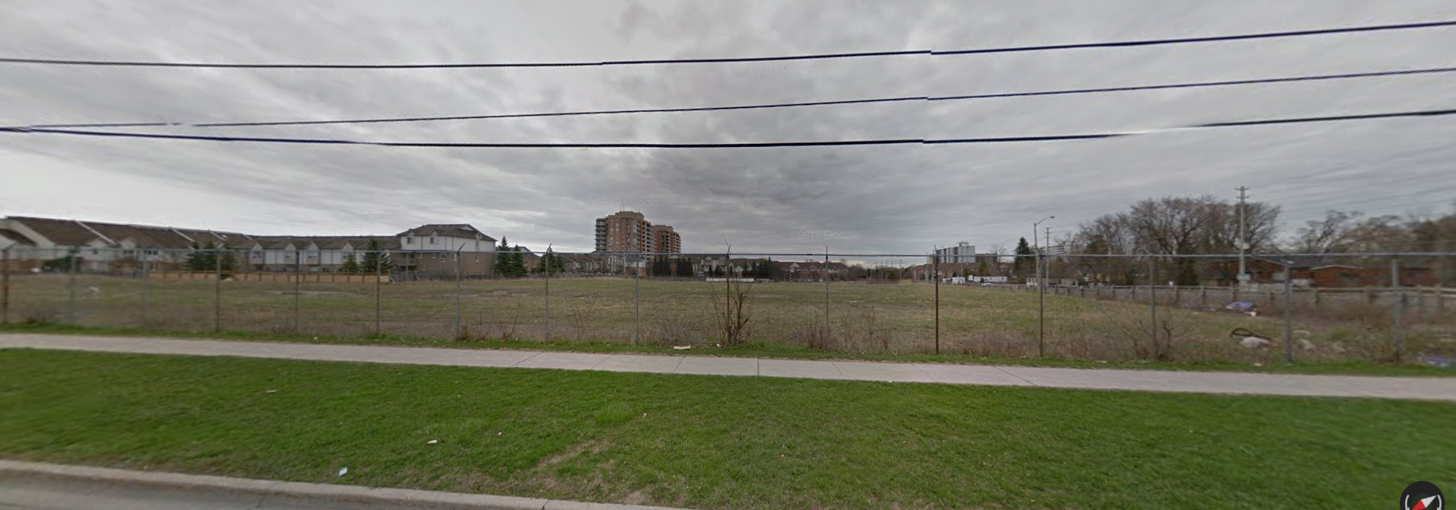

Figure 1. A patch of ugly bare land on Cawthra and Atwater

On the corner of Atwater and Cawthra in Mississauga there is a patch of bare land about 100 metres by 100 metres.(Figure 1) This is a huge problem it is ugly and a huge waste of space. There is so much need for land in this area and a huge amount of residential zones around the area they should create a small commercial area in there. With about 10000m2 of land they should build a small plaza with walkable roads and dense stores. It would create lots of economic opportunities for the surrounding community and a friendlier/ more environmentally friendly community. Also it is very ugly and lowers overall happiness it also might prevent people from moving in to the area if they think the area does not look nice.

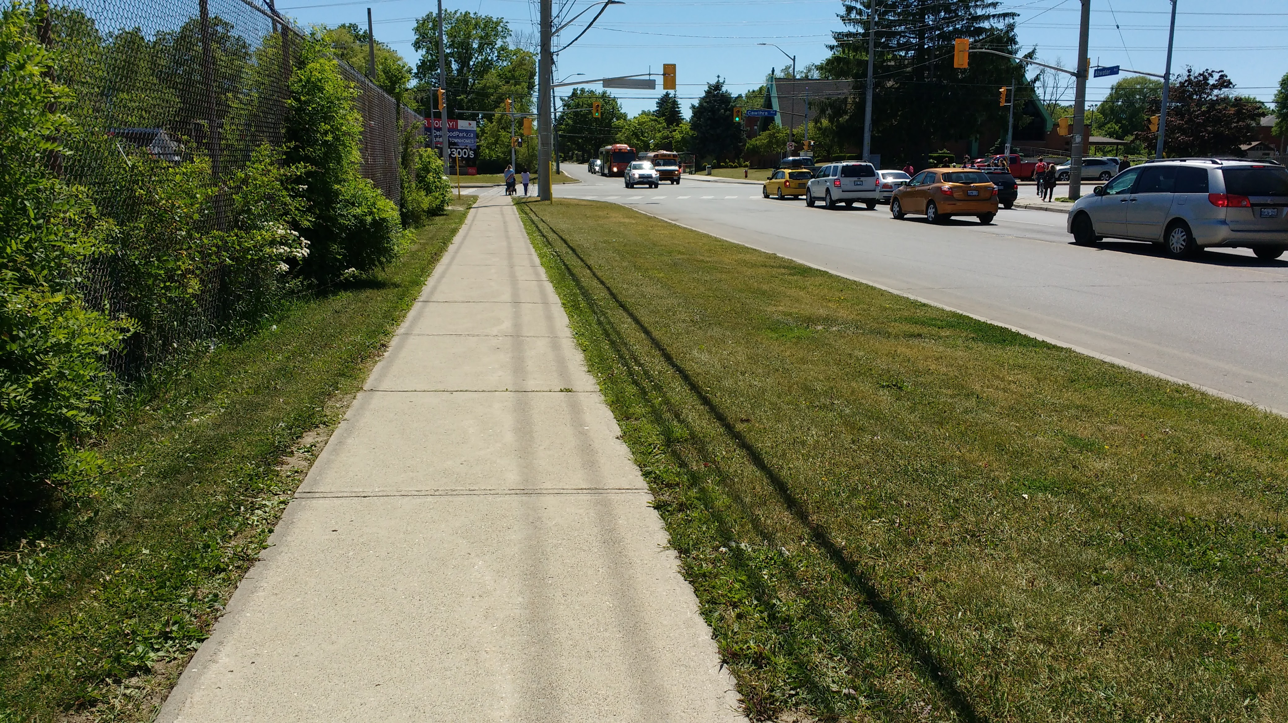

Figure 2. A long stretch of road with residential

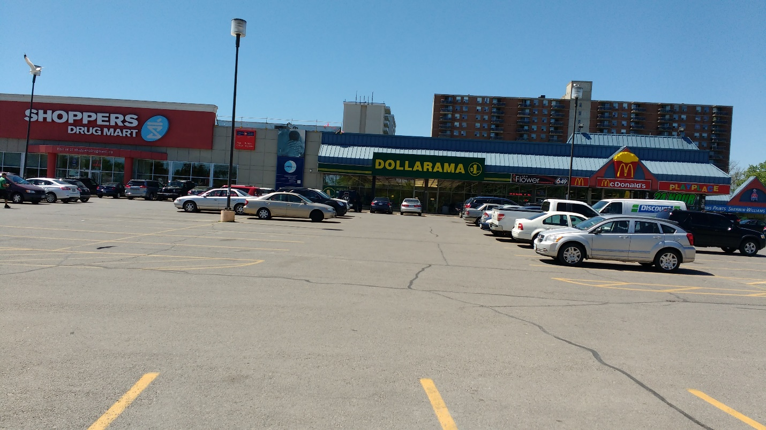Figure 4. A long stretch of residential area without any commercial zoning.

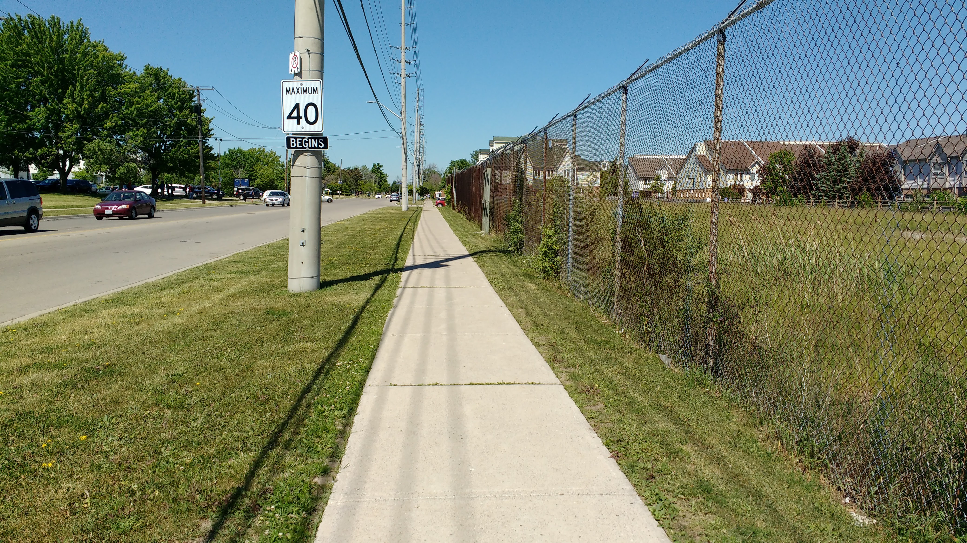

Figure 3. A plaza with a giant parking lot with residential zoning far away

Cawthra road specifically the area around Cawthra secondary school and the Carmen Corbasson center (Figure 2,4) is really badly designed and zoned. The areas roads are so large but the sidewalks are so thin. This creates a requirement to drive everywhere and a deterrence to walk anywhere. This creates lots of pollution and traffic problems which overall lowers average happiness and danger. Also the entire area for just about 1km each way is just residential this also provides a requirement to drive. The zoning should have required another place to build commercial areas and job opportunities.

On Lakeshore road east there is a huge plaza (Figure 3) built with a good intention. There are a lot of dense stores with a nice walk able area however there is a huge problem. There are no houses; the whole idea is smart however the only way you can get to this plaza is if you drive there. The whole point of this new urbanism design is that the places contain dense housings and close shops stopping people from driving however there is a huge parking lot there incentivising people to drive there. This creates pollution and the sidewalk is small so nobody walks in the place. This plaza had so much potential however since nobody lives near the area it is essentially the opposite of a new urbanist design. However it does have dense shopping areas, small and diverse types of businesses but due to the lack of houses they were forced to set up a giant parking lot so there could be no pedestrian roads or outdoor dining.